LAB 5: Retrieving Data from the Database
Aim
To retrieve data from the SQL Server database using Entity Framework Core.

Objective
- Retrieve all records using ToListAsync().
- Retrieve a record by its primary key using FindAsync().
- Retrieve a record based on a condition using FirstOrDefaultAsync().

Tools Required
- Visual Studio Code
- .NET SDK
- SQL Server Express
- SQL Server Management Studio (SSMS)
- Entity Framework Core

Procedure
Step 1: Retrieve All Products
Used the ToListAsync() method to retrieve all product records from the Products table and displayed them.
var products = await context.Products.ToListAsync();
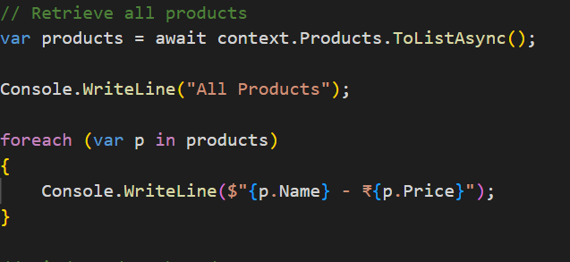
Step 2: Retrieve Product by ID
Used the FindAsync() method to retrieve a product based on its primary key.
var product = await context.Products.FindAsync(1);
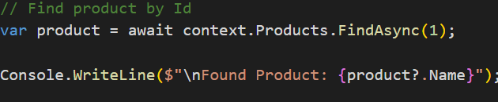
Step 3: Retrieve Product Using a Condition
Used the FirstOrDefaultAsync() method to retrieve the first product whose price is greater than ₹50,000.
var expensive = await context.Products.FirstOrDefaultAsync(p => p.Price > 50000);
.
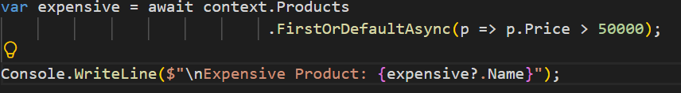
Step 4: Run the Application
Executed the application using:
dotnet run
The product details were displayed successfully in the terminal.
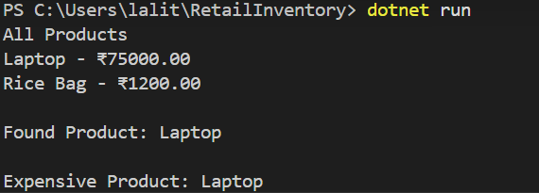
Step 5: Verify the Data
Verified the product records in the Products table using SQL Server Management Studio (SSMS).
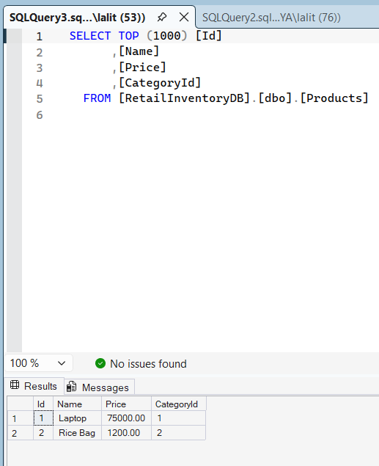

Methods Used
Method | Purpose
ToListAsync() | Retrieves all records from a table.
FindAsync() | Retrieves a record using its primary key.
FirstOrDefaultAsync() | Retrieves the first record that matches a specified condition.

Result
The product data was successfully retrieved from the SQL Server database using ToListAsync(), FindAsync(), and FirstOrDefaultAsync() methods in Entity Framework Core.

